ASSIGNMENT 4
- Display all salespeople
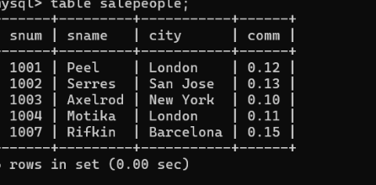
- Display all customers.
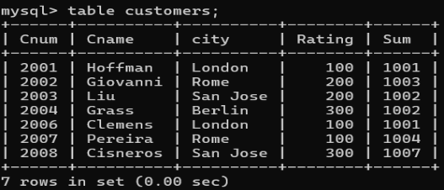
- Display all orders.
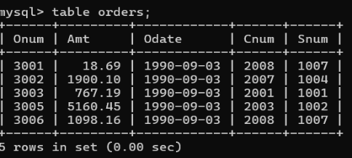
- Show names of all salespeople.
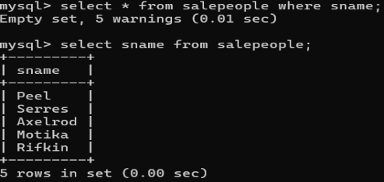
- Show customer names and ratings.
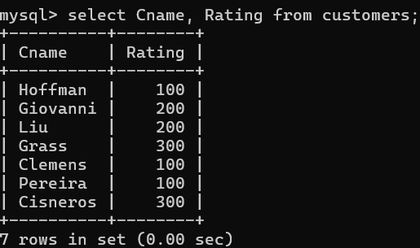
- Find customers from London.
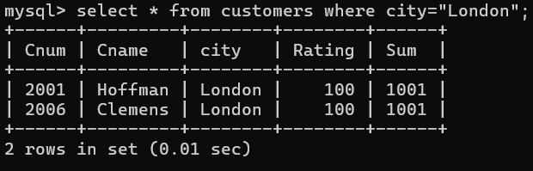
- Find salespeople from London
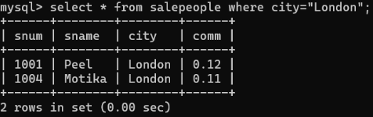
8. Find orders whose amount is greater than 1000.
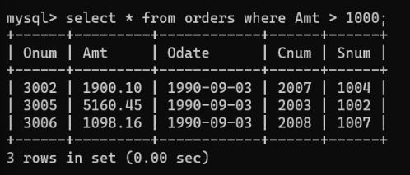
9. Find customers with rating 300.
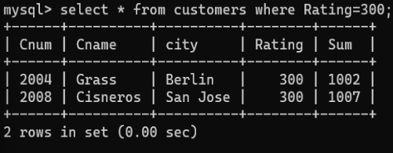
10. Find orders placed on '04-OCT-1990'.
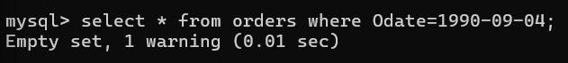
11. Display customer name and salesperson name.
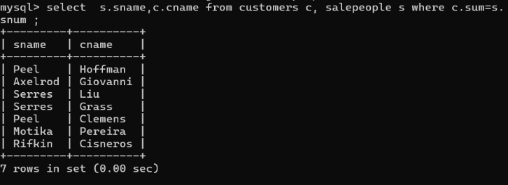
12. Display order number, customer name, and salesperson name.
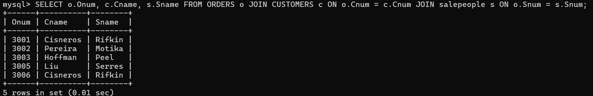
13. Display all customers and their salespeople.
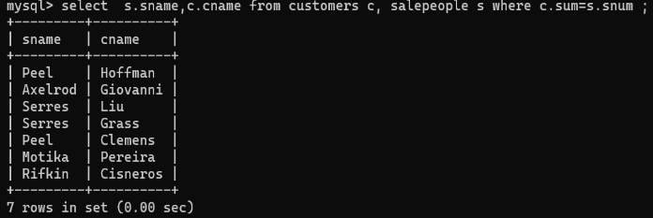

14. Display orders with customer city.
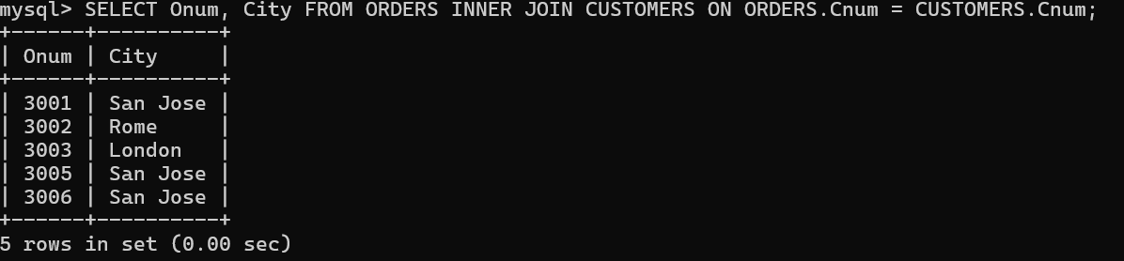
15. Update commission of salesperson 'Peel' to 0.15.
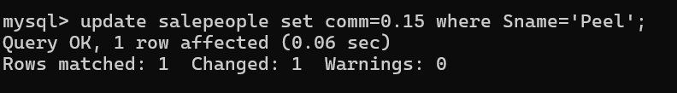
16. Increase commission of all salespeople by 2%.
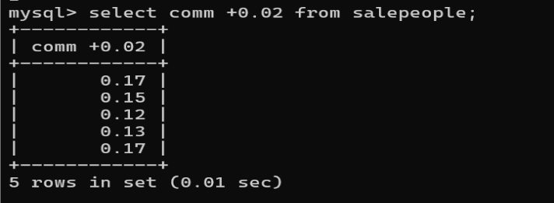
17. Change city of customer 'Hoffman' to 'Paris'.
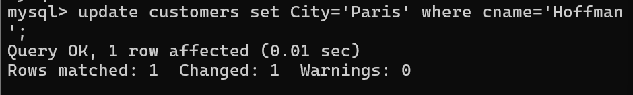
18. Update rating of all London customers to 200.
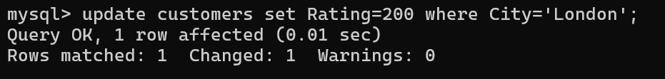
19. Increase order amount by 10% for orders less than 1000.
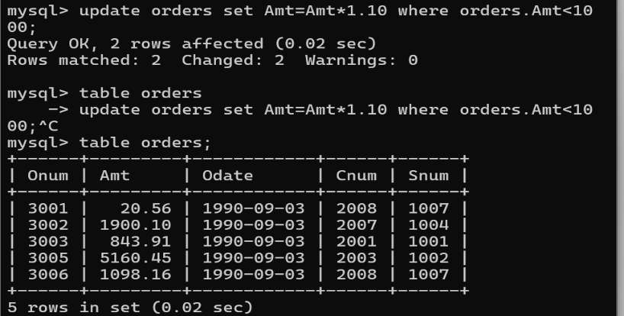
20. Delete customer with Cnum = 2008.
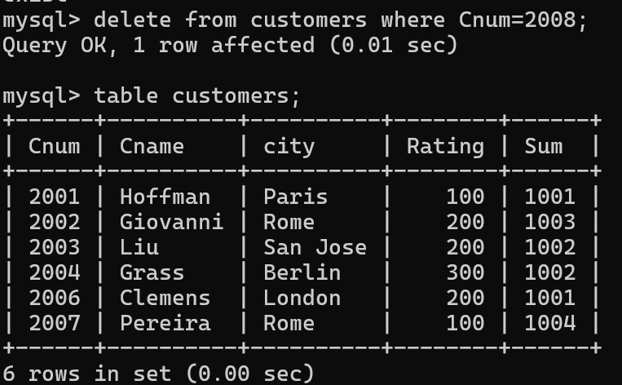
21. Delete orders with amount less than 100.
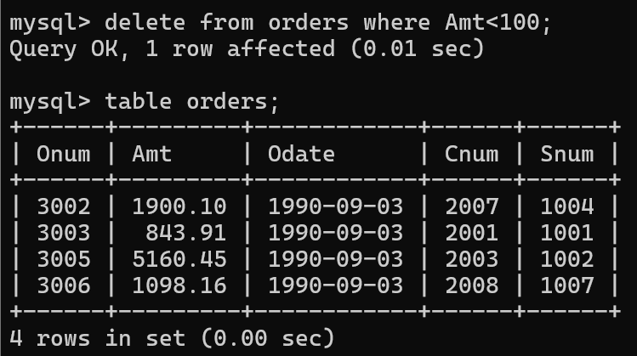
22. Delete all customers from Berlin.
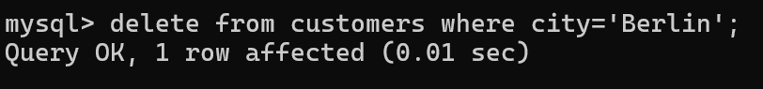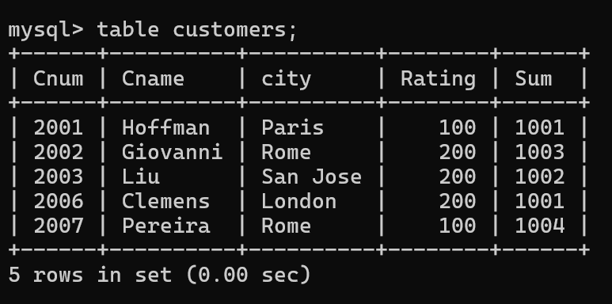
SQL JOIN
Exercise Questions
1. Display Student Name and Department Name.
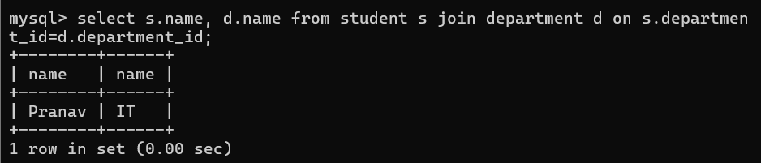
2. Display Roll Number, Student Name, and Department Name.
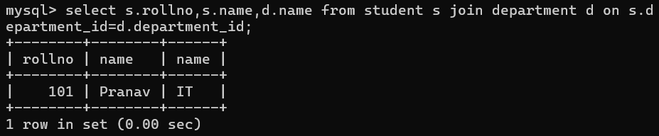
3. Display Students Belonging to the IT Department.
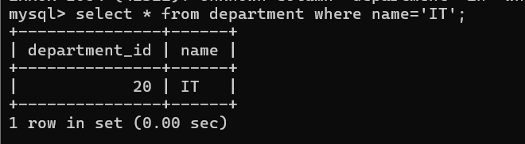
4. Display Students Having Marks Greater Than 80 with Their Department
